Fedora Linux

Operating system

Joven digo

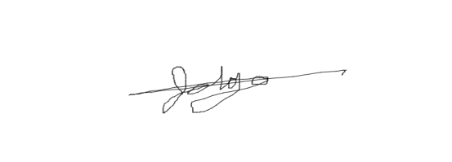

**The publisher**

**Table of contents**

**Chapter 1 01**

**History and Introduction of Fedora Linux**

**Chapter 2 05**

**Process management**

**Chapter 3 10**

**Cpu scheduling**

**Chapter 4 15**

**Memory management**

**Chapter 5 20**

**Storage management**

**Chapter 6 30**

**I/O management**

**Chapter 7 35**

**File system**

**References 40**

**Chapter 1**

**History and Introduction.**

**Fedora Operating** **system** or commonly known as **Fedora Linux** . it is a free open source Linux based operating system. Fedora was developed within six to eight month of release cycle process design as a secure and general purpose OS under by fedora project that sponsor and supported by the red hat as long as with OS.Fedora has derived from the name Fedora Linux it was a volunteer project that provides extra soft ware for Red hat Linux . Warren Togami he is the man behind the Fedora Linux project. **Warren Togam**i is a  Director, Platform and Technical Project Manager at Blockstream. He also receives Bachelor Degree from in Computer Science from the University of Hawai in 2005. followed by a Master of Business Administration (M.B.A.) from Shidler College of Business in 2014.That’s why Fedora Linux project is from the University of Hawai. **Togami** started the Fedora way back 2002 as an under Graduate project in University of Hawai . **Fedora Linux** Intends to provide a single repository for the third party soft ware packages so that non Red hat Repository is easy to find develop and also to be use.According also to fedora project “it is always to anyone to use modify and also distribute” its because of Fedora project was free and open source plat form for hard ware clouds and also container that based on the Linux OS kernel architecture.The difference between the Fedora Linux and also the Red hat Linux was fedora’s Project repository Development would be collaborative with the Global Volunteer community. Until that Fedora Linux was absorbed by the Fedora Project carrying with this collaborative approach.Fedora Project was stared as a Red Hat Linux A leading provider of of open source solutions nd this operating system was was suitable as personal or even professional use. **Fedora Linux** was also Known for its rapid release cycle that means new version of operating system was released regularly typically every six months.back in 2003 Fedora Linux and also the Red hat Distribution Linux has a connection and it is contains about the explaining that From Fedora name itself to “fedora” was referring to the characteristic of red hat “ Shadow man ” logo. Before shadow man it was called first as “ Red hat man ” it was the figure under the red fedora personified company . Red Hatters knew that the shadow man was benevolent, liberating figure, introducing then-taboo open source software to the mainstream . As Linux Distribution Fedora is the most popular along with the other Linux Open sources like the Ubuntu, Cent OS, Debian, and Open Suse. There are over 100 Distros based on the fedora, Including the Red Hat Enterprise Linux And Risi OS.In 2003 Fedora was launched after that the Red Hat Linux was discontinued. It was the Red Hat only official supported Linux Distribution while the Fedora was community Distribution Red Hat Enterprise Linux branches was release from Versions of Fedora. Fedora has 35 version releases but then is because of its rapid version releases that means in every 6 months the fedora fedora new Versions where release it means that it will continue and grows up. While the First version of Fedora was the fedora 1. Fedora 1 is also known as Fedora Core 1 It was Released on November 6 2003 it has also code name known as “ Yarrow” . It was the worlds premiere open source soft ware provider in its time.It is the very first version that released by the fedora project. Fedora core 1 provides complete Linux platform built exclusively from open source soft ware it is available in no cost in shot it was free and it also serves the needs of the technology Enthusiast.way back to its versions that consist of 35 versions 21 of it has a code name and all of this code name is name not because they want it there is also reason and meaning behind on its code name. First the yarrow it is a plant with many uses. Prior to the use of hops in the flavoring of beer, yarrow was used for this purpose Next is the Tettnang it is a city in Germany that is a producer of hops. Hops is a climbing plant it was found in the country of United States, Germany, China, Czech Republic, Poland Slovenia and also in other selected countries. But it is Originated form the country of china it was a recipe in a beer and according to it it was banned for brewing of ale which means ale is a type of beer with a bitter Flavor with high content of alcohol.Heidelberg It is a city in Germany and one of the Distributor of beer.next of it is Stentz it is a french winery. While in core 5 it is named as the Bordeaux it was wine producing region In France also a comic book character as well as. Next is Zod also known character in the DC comics universe as well as an independent record label. Moon shine the seventh version of Fedora project independent record label as well as name of the movie. Before fedora 7 Fedora is known Fedora core it names after the one of two main repository the core and also extras. Fedora core is contained all the base packages.That the Operating System base packages was being required while other of Its packages is distributed along with the installation of CD/DVD. And was maintained by the Red Hat Developers. Fedora Extras was the secondary repository that was included since before Fedora core 3. Upon Distinction the Fedora 7 The fedora core and fedora extras was eliminated. Back to the code names of other Fedora version we have already tackle about the 7 version that the Fedora Core and also Fedora extras has been included we have the eight version it has the name of werewolf known as a movie name about character that turn into were wolves. And also in the ninth name Sulphur also known element that causing adverse reaction. Cambridge in tenth City in the united states, also originally code name of Red Hat Linux 10. Leonidas in eleventh known as the ship of united states navy. Constantine in twelfth the name of Township in St. Joseph County, Michigan in the United States, as well as a name of a bay in the United Kingdom.Goddard in thirteenth also known Rocket Scientist. Lauphlin in fourteenth Means that like Robert H Goddart a professor of Physics its like Robert Lauphlin. Lovelock in fifteenth City in the state of Nevada , and so is Love lock. Verne in sixteenth Just like James loverlock a futurologist and so was Jules Verne. Beefy miracle in seventeenths is something that never been observe. Spherical cow in eigthteenth also known theorotical thought experiment. Schodingers cat also a theorotical thought experiment. Heisenbug is a term for a software bug that seems to disappear or alter its behaviour when one attempts to study it.While in the version of 21 up there is no more code name instead it is number that translated Into word.**Fedora Linux** uses and picks theses unconventional code names for typically reflect a there or a historical significance for those versions . The newest version where the fedora Linux releases is the fedora workstation 39 on 7th of november and this version has GNOME 45 that brings better performance and also usability enhancement it includes here the better switcher and also improve image viewer.Fedora cloud will be officially also in the Microsoft Azure and it also includes gcc 13.2, binutils 2.40, glibc 2.38, gdb 13.2, and rpm 4.19. It also has updates to popular programming language stacks, including Python 3.12 and Rust 1.73.In **Fedora Linux** because of its capability that open source it has capable to use by anyone who needs to build tailored solutions in a comprehensive and reliable way. **Fedora Linux** has a rich features and essay to be use by many user. It can also supports multiple architectures.last in his multi purpose system it includes many Software packages like including basic desktop applications, games, development environments, web services and database services.**Fedora Linux** is constantly being updated by its vast and growing community. Everyone can join enjoy the community and contribute to the Fedora Project to advance Fedora and keep it open source, regardless of their skill levels or preferred languages.In fedora Linux for its security it incorporate many security features and technologies. It includes the ExecShield along with Security enhance Linux or much likely call SELinux. In SELinux it provides many security policies which the Linux based distros missings. It is capable in protecting user system on malicious software and threat actors without interfering with the user's day-to-day task workflow.There is also other key benefits of the Fedora Linux theses are incorporates new features released into other Linux distros by the Fedora community,supports ability to test new software versions before production deployment,provides spinning tools so anyone can create their own Linux-based distro,supports virtualization,updates automatically,supports multiple file formats,includes many graphical and utilities tools. As well as in fedora Linux there is also different Editions where it has and this editions helps the fedora Linux to maintain its Excellent Credibility being a good open source Linux and theses Editions are.Fedora Work station it is user friendly among to the user laptops or personal computers because it has a comprehensive tool for the developers and also software makers.We have also the fedora server which capable of control and manage infrastructure and services.fedora Cloud is a powerful and minimal base OS image with tailored images for public and many private cloud applications. Fedora Iot trusted and reliable to build strong internet things.Fedora CoreOS focusing on the automatically updates other fedora options are available. Fedora Spins For suitable installation specially on the laptop users and personal computer users. Fedora labs curated software and content that can be installed as stand alone full version. Fedora alt downloads specially alternatives for testing and also in architectures. Fedora is fast moving Linux distro that is focusing in innovations Every new release includes the latest free and open source programs, tools and software libraries. Its fast release cycle and innovative tool set make Fedora Linux suitable for the following Technology professionals, digital arts, software developers, game developers, also academics and students.Fedora Project has 4 foundation principles this principle is to maintain the fedora Linux is reliable user friendly and also safe to use. First of it is Freedom The main goal is to maintain software and content freedom by using free alternatives to proprietary code and content and by limiting the effects of proprietary or patent-encumbered code on the Fedora Project. Second is Friends people of walks of life work together and find concencible to advance free software to improve Fedora Linux.Third is Features it creates technical features that make Fedora powerful, Flexible and usable for a wide spectrum of user. The last feature was First rapid release cycle enables the community to focus on innovation and maintain the forward momentum of fedora’s technological progress.

**Chapter 2**

**Process Management**

Fedora Linux is a open source base operating system means it is open for all user specially to the testers, developers or even people that has machine that can achieve the requirements of the fedora Linux which is laptop or even personal computers.It is also handled by the Kernel and user space utilities just like what other Linux distributions. What is kernel? Kernel is the one who providing the functionality for managing processes which means it is the main core for the processing of the Operating system. What is the use space utilities? User space utilities is able to control the process means that in every process that providing by the kernel user space utilites is able to control it Fedora Linux also is has a Process managements that implies to have smmoth flow and organized of its system to terminate any kind of bugs and muck easier use for the Fedora Linux users. Fedora Linux has also providing multiple kind of tools to motion the process activity and resource usage, modify process and also terminate processes it is also identified by process id or what we called pid. Which is sequentially assigned There is small set of information associated with each process it includes nice It is used to alter and a process scheduling priority. It determines how much cpu time is the process and receives . Its priortize on calculation based upon this factor and also how much the cpu time the process ha receive ad how many input/output operations recently performed.Parent process id (pid ) always were the process is started . if the pid process is disappear then it is replaced by 1 which call (*init process*).Real user id and also effective user id this numeric id of the user actually running in the program and the effective user running the program. This could be much different if when the *suid*  mechanism was active. And also effective user id remains effective even suid programs calls the non suid programs.Umask it is th permission receive from the parent process and also we have tty it is the terminate where associated with the program if it is applicable. This permits all programs on that terminal to receive a hangup signal when the terminal is lost which in this case when a tele phone modem calll is hung up , a terminal window is closed or a remote class telnet/ssh session is teminated. This valiu is inheritd by child process.Fedora Linux has also features here are the list of the feactures of the fedora Linux.

* Fedora OS offers many architectures.
* Fedora OS is a very reliable and stable operating system.
* It provides unique security features.
* Fedora OS provides a very powerful firewall.
* Fedora OS is very easy to use.
* It supports a large community.
* Fedora OS is actively developed.
* Fedora OS is an open-source OS.
* The interface of Fedora OS is very attractive.
* This operating system offers live mode tools.
* This operating system enhances internet speed.

Fedora Linux has comes with many preinstalled application sand also tools all of them is the  *internet Browsers, pdf, and word file viewer, Pre installed Games, Libre Office suite, Programming language* .Fedora is also *Stable, Secure , and lightweight operating system.* It can support different types of architectures it includes the *IBM Z, AMD X86 - X64, INTEL I686, IBM POWER64LE AND ETC.* Fedora Linux has also its specification why fedora Linux has specification? It s because it is open source its requirements is to become user friendly that enables users to perform their task easily and also efficiency. And also it has a reputation for concentrating on invocation, developing new technologies, and closely working with the up stream Linux community. It also applies changes in upstream specifically for fedora Linux guarantees that the modification are available to every Linux distribution.here is the different specification of the Fedora Linux.

* Package management
  + Almost all edition of Fedora Linux utilize rmp package management system with DNF s a tool to handle the rpm packages. The DNF is utilizing the Libsolv where is an external dependency resolver and also Flaptak by default included and supports snap packages. Also fedora Linux utilizes the Delta RPM if the packages are updating it offers the delta packages .The only modifications between new package and the installed one are downloaded is decreasing bandwidth consumption and also network traffics.
* Security
  + Fedora Linux has utilize the Security Enhances Linux it means that in implements a range of security policies such as mandatory access controls which Fedora Linux ha early adapted on it. It also offers hardening wrapper and so hardening of its packages by utilization compiler features like pie.
* Software

Fedora Linux has available preinstalled with a huge variety of soft ware such Firefox and a;sp LibreOffice there are the additional software from the software repositories it can be installed with the Gnome many and different repositories can additionally included in the system so that software not present Fedora Linux can be easily installed. There is also software that is not available y official; repositories like because of its due to it doesn’t meet the definition of free software of fedora Linux or its distribution is disrupt

* System installer
  + Fedora Linux Utilize anaconda.

In Fedora Linux it has also Editions this editions started in fedora Linux Version 30 - version 35 it compose of 5 different editions 2 of these editions is treated as secondary edition and the rest of the 3 is primary editions.

**Primary Editions**

* Work station
  + The target of this edition is user that ant powerful, user friendly and also reliable operating system for their desktop and laptop computers. By default Gnome is is providing But other laptops or personal computers can also be installed and can be installed as spins.
* Internet of things
  + The Linux are tailored to execute on x86_64 processors.
* Servers
  + Its management targets is for the servers. This version does not provide a desktop environment but anyone can be installed . It [provides fedora modularity and additional support for other update steams for famous software like Go and node.js from Fedora 28.

**Secondary Editions**

* **coreOs** 
  + This is the succession of the Container Linux and also Fedora Atomic host after the fedora 29 Version . This offers the Fedora Linux image which contains only the bare essentials . it was develop for distribution in cloud computing also offers Fedora CoreOS images optimized minimal images to deploy containers.
* **Silver Blue**
  + It is an Immutable desktop OS. All silver blue installations are identical to all other installations of a similar version ans it never modifies as its used. It also proposed to make the OS more stable, establish a platform, easier to develop and test, and less prone to errors for containerized applications and container-based software development.
* **Labs**
  + Fedora project also distributes distinct variations known fedora labs, it is similar with the debian blends . It is created with the specific groups of software packages, targeting unique interest like scientific computing , robotics, designs, security, and gaming
* **Reixes and Spins**
  + Fedora Linux is also distributes distinct variations known as “Fedora Spins”. It is fedora Linux with distinct desktop environments. It permits unofficial variants to utilized the “Fedora Remix”term without prompting for further permission
* **Architectures** 
  + ARM-HFP, ARM AARCH64 AND X86-64 are the primary architectures offered bu Fedora. Fedora also supports RISC-V, MIPS- 64el, IBM Z and IBM Power64le as secondary architectures as of version35.
* **Alternatives**
  + Fedora Projects also distributes many other version with fewer use cases than discuss above .like more minimal installation images and network installers

**Fedora Project**  is very flexible and powerful and flexible OS. It keeps control with your infrastructure and also services. It also offers the latest data center technologies. Theses are the different kind of editions from primary to secondary editions that under by the process management of fedora Linux

**Chapter 3**

**CPU scheduling**

CPU Scheduling is a process that allows to use the cpu while the execution of another process is on hold or what we call in waiting stage why we need to use scheduling? Its because it decides which process and it also determine which thread use to occupy resources

**Scheduling Criteria is concist of:**

* *CPU utilization*
  + Make out the best use of cpu and not to waste any cpu cyle
* *Throughput*
  + Total number of process complete per unit
* *Turnaround time*
  + Amout of taken time period to execute particular process
* *Waiting time*
  + Sum of periods spent waiting in the already queue
* *Load avarage*
  + average number of processes residing in the ready queue waiting for their turn to get into the CPU.
* *Response time*
  + Amount of time it takes from when a request was submitted until the first response is produced.

**5 Objectives of CPU scheduling**

* Fairness
* Priority
* Efficiency courage good behavior
* Support heavy loads
* Adopt to different environment

**Fedora Linux CPU Scheduling**

* Fedora is a Linux-based operating system that showcases the latest in free and open source software from “ Red Hat” company.
* Fedora is always free for anyone to use, modify and distribute.
* It is built by people across the globe who work together as a community

Although CPU has many sharing algorithms to dealing with task scheduling in both Windows and Linux OS.There are some algorithms have been designed to used uniquely by Linux OS.

**Examples of CPU scheduling that Linux use**

* O(n)Scheduler
  + Was default in 2.4
* O(1)Scheduler
  + was default in 2.6 before 2.6.23
* Complete Fair Sheduler
  + default scheduler since 2.6.23 onwards
* Brain Fuck Scheduler
  + popular third-party scheduler available as a set of patches
* Earliest Deadline Scheduler
  + scheduler is available since 3.14 designed for real-time workload

Completely Fare Scheduler

* It is not existent but CFC tried to emulate such a processor in soft ware.
* In a real world, only one task can be allocated to cpu at a particular time.
* all other tasks wait during this period. So, while the currently running task gets 100% of the CPU power, all other tasks get 0% of the CPU power. This is obviously Not Fair

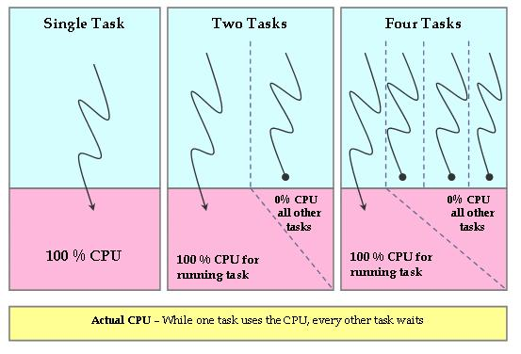

CFS Red black tree

* The task were able to maintain in a time order.
* It may called self balancing binary search tree
  + Balancing is preserve by painting each node with one or two colors in a way to satisfy certain properties
  + The balancing of the tree guarantee that no leaf can be more than twice as deep as others and the tree operations can be performed in time
* It will switch to the left most task in the tree that is the one with the lowest virtual runtime to maintain fairness

**Fedora uses Red Black Tea**

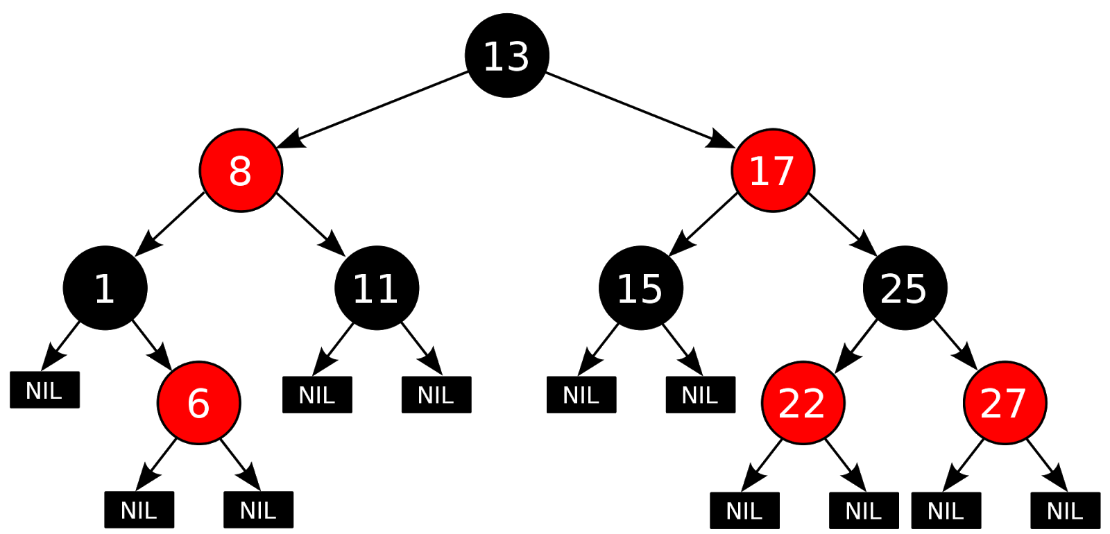

* The key for each node is the v runtime of the corresponding task
* To simply pick the next task take the left most node

**Earliest Deadline first**

* An important class of scheduling algorithms is the class of dynamic priority algorithms
  + The priority of a task can change during its execution
  + The priority of a task does not change

**The most important (and analyzed) dynamic priority algorithm is Earliest Deadline First (EDF)**

* The priority of a job is inversely proportional to its absolute deadline
* The highest priority job is the one with the earliest deadline
* If the the two task has same deadlines.Choose one of the two at random.
* The priority is dynamic since It changes for different jobs of the same task

**Earliest Deadline First**

* Theorem Given a task set of periodic or sporadic tasks, with relative deadlines equal to periods, the task set is schedulable by EDF if and only if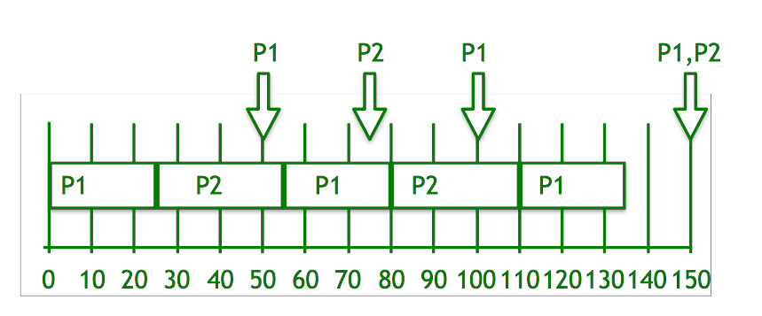

**Steps for solution:**

1. Deadline pf P1 is earlier, so priority of P1>P2.
2. Initially P1 runs and completes its execution of 25 time.
3. After 25 times, P2 starts to execute until 50 times, when P1 is able to execute.
4. Now, comparing the deadline of (P1, P2) = (100, 75), P2 continues to execute.
5. P2 completes its processing at time 55.
6. P1 starts to execute until time 75, when P2 is able to execute.
7. Now, again comparing the deadline of (P1, P2) = (100, 150), P1 continues to execute.
8. Repeat the above steps…
9. Finally at time 150, both P1 and P2 have the same deadline, so P2 will continue to execute till its processing time after which P1 starts to execute.

Fedora Linux use this CPU scheduling for its better performance purpose in every operating system it has different CPU scheduling its about how it is fit on them.

**Chapter 4**

**Memory Management**

Managing process is a running instance of a program.If you run a program twice then two process were created. In order to manage a Fedora system effectively, you must be able to monitor control and processes.

**Memory management technique that Fedora uses**

* *Garbage Collection*
* *Swapping*
* *Virtual Memory*
* *Memory heirarchy*
* *Over Commit Accounting*
* *Out of Memory*
* *Drop Caches*

**Garbage Collection**

It is a form of technique which automatically the operating system removes the object or even data or other region of the memory which are no longer in use by the system or the program.

* Running
  + This is a stage where the operating system identifies the unwanted Objects.it has builds or data and they are detached from certain tags according to garbage collection policies set by fedora and it also based in the tag signature or package.
* Trashing
  + Second stage where the system over looks the Objects.has builds or data that is untagged in pruning stage then after builds and data was tagged with the trashcan tag which instructs the system to send theses builds for detection. The work of garbage collector is sending a certain objects. That builds or data for detention only if It meets the following requirement.
* Deleting
  + This is the final stage in garbage collection where in this stage all objects builds or data are examined for the last time for any mistakes in their tags. It is usually deleted after it has been tagged with the trashcan tag for more than grace period.

**Swapping**

This is the last and final stage which when the amount of physical memory is full. And also if the system needs more memory and ram is full process are swapped temporarily out of main memory to secondary stage. And making the memory available to other processes.

**Virtual Memory**

It is implemented in fedora since it is a multitasking and multi user operating system. Theses features requires necessary protection and ability to execute different process simultaneously whose cumulated process in the system

It is basically extending the users primary memory by the considering the hard disk as if it were and additional Ram.

It also allows the computer to look at areas of RAM which have not been use for a while and copies those areas onto the hard disk.

**These are the advantage of Virtual Memory**

* It is allowing the system to process to function as if it has more Ram than it actually does.
* It can run on a system even though there isn’t enough primary memory required fr the program or process to run.
* User is not allowed or even not needed to buy expedience Ram because of the hard disk.

Disadvantage of Virtual Memory

* There will be change to the system performance specially in its loss if the system relies too much on the virtual memory.
* The virtual memory requires a allocation of certain portion of hard disk space for its use.
* The system might be unstable because of its constant swapping information between the hard disk and also in the RAM.

**Fedora Memory Usage**

Memory usage in real terms it isthe way of the operating system which it use the memory in not self evident. In fact some ingenious, their techniques are at play. They help your OS use memory more efficiently without involving user.IT relies on sets of function and function is collected in the libraries. And this libraries are installed on your system and in Fedora rpm packaging is the one in use because It ensures that when you install an app any libraries on which it relies are installed too. When an app runs operating system it doesn't necessarily load instead all the information it uses into the real memory. It builds a map to the storage where that code is stored called the Virtual Memory. It only loads the part where needed only . if its no longer needed then it will release or swap them out as appropriate.in many case the app can map a very large amount of virtual memory while using the less memory in the system at one time. It can also map RAM that the system has available. In addition the related application is relying on the same libraries . Linux kernel in fedora system shares the memory between applications loading multiple copies of the same library for related apps is doesn’t need anymore. Because it similarly separate instances of the same app too.

**Viewing memory usage in TOP**

**Ways to view memory usage in top**

* Open a terminal
* Run the top command
* Pres Shift + m

Here is the example output

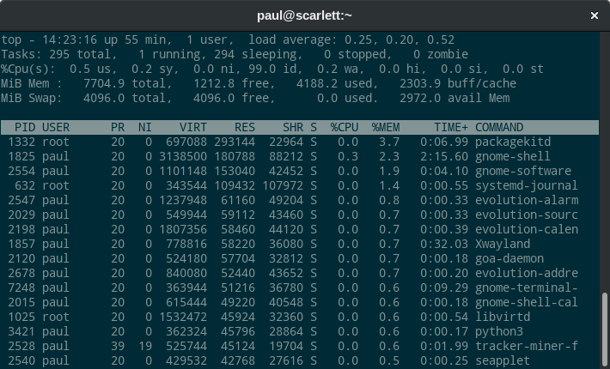

There are three columns that showing memory usage to examine the **VIRT, RES and SHR**

Kilobytes is the measurement that currently shown

Virt column is where the virtual memory mapped for this process. VIRT was built in number of lower and higher level libraries. The system must map each of those to ensure they can be loaded when necessary.

RES column shows the actual memory is consumed by the app In the case of GNOME Shell, that’s about 180788 KB. The example system has roughly 7704 MB of physical memory, which is why the memory usage shows up as 2.3%

While in the SHR column it shows other apps can also use the library functions.This means the GNOME Shell is using about 92 MB on its own not shared with other processes. Notice that other apps in the example share an even higher percentage of their resident memory. In some apps, the shared portion is the vast majority of the memory usage.This is the memory management rather the memory usage of fedora Linux use.

**Chapter 5**

**Storage Management**

Managing files it is largest part of the system where it involves in dealing with files and diirectories. It may include creating directories, copy directories, moving files, directories around and also deleteng them. Fedora provides a powerful set of tools for managing files from the shell prompt as well as graphically.

Fedora masters directory is called the roon directory it contains files and directories each of those may in turn contain other files and directories.For each user, one directory is designated as the home directory, and that is where that user stores her personal files.and also each process has a current working directory on the system which is the directory that it access by default unless directory is explicity specified.The root directory is always the same system-wide and the home directory is consistent for a particular user but varies from user to user and the current working directory is unique to each process and can be changed anytime.

A path name it specifies how to find a file in the file hierarchy. It has also three different path name scheme that can be used based on the three different starting points root, home, current working directory.Each of scheme specifies the path from the selected starting point to the desired file.

**TableÂ 4-4.Â Absolute, Relative, and Relative-to-Home pathnames**

| Scheme |  | First characters of pathname | Relative to... | Example |
| --- | --- | --- | --- | --- |
| Absolute |  | / | Root directory | /home/chris/book/chapter/one.odt |
| Relative-to-Home |  | ~ | Userâs home directory | ~/book/chapter/one.odt |
| Â |  | ~ chris | Home directory of chris | ~chris/book/chapter/one.odt |
| Relative |  | (Anything other than / or ~) | Current working directory | chapter/one.odt (Assuming that /home/chris/book is the current directory) |

The special symbles both same directory andaslo the parent directory as very useful in path of names for example if youe current directory is home/chriss/book/ then invitation refers to home/chris/invitation.

Fedora uses the standard set o directories that derived from historical conventions.The lsb project ant the kernel.

TableÂ 4-5.Â Key directories in Fedora Core

| **Directory** | **Purpose** |
| --- | --- |
| /bin | Basic binaries (programs) needed to start the system. |
| /boot | Files used during the boot process, including the boot menu and kernel. |
| /dev | This directory contains special files that are actually connections to devices, such as keyboards, mice, modems, printers, sound cards, and so forth. When you read data from a special file or write data to it, youâre actually communicating with the associated device. |
| /etc | System configuration files (sometimes regarded as the âhome directory for the computerâ). |
| /home | Usersâ home directories, for the storage of personal files. |
| /lib | Libraries. |
| /lost+found | A directory used to recover files in the event of filesystem damage. Any file that has been disassociated from its name is placed here during filesystem recovery. |
| /media | External media (floppy disks, USB drives, digital cameras, optical disks) that have been mounted. |
| /mnt | Historical location for mounting storage devices, many of which have now moved to /media. |
| /opt | Optional, add-on software. The definition of add-on software is subjective; if you obtain OpenOffice.org directly from the openoffice.org web site, it will be installed here, but if you install the version distributed with Fedora, it will be installed in /usr/bin. |
| /proc | Per-process status information plus system information. |
| /root | Home directory for the root user (superuser). |
| /sbin | Basic system administration binaries. |
| /selinux | Files for Security Enhanced Linux. |
| /sys | System device information. |
| /tmp | Temporary file storage. |
| /usr | User data (years ago, home directories were also stored in /usr). |
| /usr/bin | The remainder of the standard binaries. |
| /usr/lib | User libraries. |
| /usr/libexec | Programs that are not directly executed by the user but that are executed by another application (e.g., graphics demos for the xscreensaver program) |
| /usr/local | Local files (specific to your system configuration). |
| /usr/local/bin | Local binaries and scripts. |
| /usr/sbin | The remainder of the system administration binaries. |
| /usr/src | Source code for locally built RPM packages and the Linux kernel. |
| /var | Files that change frequently (variable), including databases, print requests, and logfiles. |
| /var/log | Various system logfiles. |
| /var/spool | Files for various queues (spools), such as print queues and file-transfer queues. |

*\** can be used in pattern matching which is very useful with several files at a time without individually specifying each filename. And also asterisk * can mach any number of characters. Square brackets[] can be used to a contain of characters example [123] even also range of characters or combined list and also range it can match any one character from the list or even range. Using !w can invert the meaning causing a match with any one character which is not in the list ar range

| **Filename** | **Description** | **Matches** | **Does not match** |
| --- | --- | --- | --- |
| a* | Any filename starting with a | absolutely.txt  a.out  albert | Albert  backup  _abc_ |
| *x* | Any filename containing an x | xylophone.gif  nexus  old.x | constantinople  ALEX |
| *[0â9] | Any filename ending in a digit | file3  menu.backup60 | file  file3a  file3.txt  416-555-1212.phone |
| [Aa]???.txt | Any eight-character filename starting with a or A and ending in .txt | appl.txt  ax42.txt  Any1.txt | application.txt  a.txt  allow.txt |
| [aâzAâZ][0â9] | Any two-character filename starting with a letter and ending with a digit | a9  G7  N3 | No  7G  XX  Fortran77 |
| [!aâzAâZ]*  [^aâzAâZ]* | Any filename that does not start with a letter | 9lives.odt  _whatever | abc.txt  Nevermore |

Linux *file names*  can be up to 254 characters long and contain letters spaces digits or even punctuation marks however names that contain punctuation marks or spaces cannot be used as command arguments unless you place quote marks around the name

**Recommendations for linux filenames**

* Start the filename with a letter or digit and also build the name from lower case letters , digits , dots , hypens and also underscore. And also donot put space on it
* Using the plural formof words is prohibited instead use single form of words. Because it is less typing and you want to have keep track of whether you choose the singular for or plural form
* In file extention gif,xt, or even odt is not recognize by the linuc kernel instead of it use traditional extentions such as .mp3 for mpz or audio files and aalso .png for portable network graphics files.

**Listing contents of directories**

* Ls command will display list of files in the current working directory

This is the example:

$ ls

4Suite crontab hosts libuser.conf nxserver

a2ps.cfg cron.weekly hosts.allow lisarc oaf

...(Lines snipped)…

* -l will change the output to include security permissions number of names user or group name filesize in bytes and the date and time of last modification.

This is the example

* $ ls -l
* -rw------- 1 chris chris 3962 Aug 29 02:57 a2script
* -rwx------ 1 chris chris 17001 Aug 29 02:57 ab1
* -rw------- 1 chris chris 2094 Aug 29 02:57 ab1.c
* -rwx------ 1 chris chris 884 Aug 29 02:57 perl1
* -rw------- 1 chris chris 884 Aug 29 02:57 perl1.bck
* -rwx------ 1 chris chris 55 Aug 29 02:57 perl2
* -rw------- 1 chris chris 55 Aug 29 02:57 perl2.bck
* -rwx------ 1 chris chris 11704 Aug 29 02:57 pointer1Ls -s -l it will display from largest to smallest.

This is the example

$ ls -S -l

-rwx------ 1 chris chris 17001 Aug 29 02:57 ab1

-rwx------ 1 chris chris 12974 Aug 29 02:57 pp1

-rwx------ 1 chris chris 11704 Aug 29 02:57 pointer1

-rw------- 1 chris chris 3962 Aug 29 02:57 a2script

-rw------- 1 chris chris 2294 Aug 29 02:57 pp1.c

-rw------- 1 chris chris 2094 Aug 29 02:57 ab1.c

-rwx------ 1 chris chris 884 Aug 29 02:57 perl1

-rw------- 1 chris chris 884 Aug 29 02:57 perl1.bck

-rw------- 1 chris chris 228 Aug 29 02:57 pointer1.c

-rwx------ 1 chris chris 55 Aug 29 02:57 perl2

**In displaying and changing current working director it has also particular command**

* Pwd to print the name of the current working directory.

This is the example.

$ pwd

/home/chris

* CD to change directory

This is the example

$cd

/tmp

To change to the foo directory

$cd

Foo

Cd can also capable to back to the directory, change to your home directory.

**Creating removing directory in your command line.**

* Mkdir is for making directory

Example

$ mkdir

Newdirectory

* -p to create chain of directories

Example

$ mkdir - p

Foo/bar/baz/qux

* Rmdir to delete directory

$rmdir

New directory

* $rmdir -r is to delete the directory and also its file

**Copying files**

* Cp to copy a command
* Mv renaming the name of the directory
* Rm to remove a file
* Rm - I to have a comfirmation before it is removing

**Creating multiple names by lingking files**

* $ls -I to view inode number of a file

Example

3410634/ etc/ hosts

* $ls -l to display number of links on a file

**Viewing of the contents of file**

* Cat to display all contents of a text fie

Example

$cat

Readme

* Less used to scroll through it

**Managing files graphically using GNOME**

GNOME is file manager is named nautilus and it permistts simple drag and drop in file management.To open a Nautilus window, double-click on the Home icon on your desktop or select a folder from the Places menu.

**To manage files start to selecting one or more files**

* Select single file
* To select several files click on a point to the left or right of the files
* To select file that are not adjacent click on the first one and then hold ctrl and click on the additional ones
* To select a consecutive range of files click on the first file and then hold shift and click on the last file

**Once you have selected a file**

* Move, copy, or link the file by dragging it between windows
* Delete a file by dragging and dropping it on the Trash icon on the desktop, by pressing the Delete key, or by right-clicking and selecting aMove to Trash
* To rename a file, right-click, select Rename, and then edit the name below the file icon.

**Managing files graphically with kde**

Same as the gnome all of the steps is similar on it like in the managing files and also once you have selected a file.

**To manage files start to selecting one or more files**

* Select single file
* To select several files click on a point to the left or right of the files
* To select file that are not adjacent click on the first one and then hold ctrl and click on the additional ones
* To select a consecutive range of files click on the first file and then hold shift and click on the last file

**Once you have selected a file**

* Move, copy, or link the file by dragging it between windows
* Delete a file by dragging and dropping it on the Trash icon on the desktop, by pressing the Delete key, or by right-clicking and selecting aMove to Trash
* To rename a file, right-click, select Rename, and then edit the name below the file icon.

This is the storage manage management that Fedora has.in usig linux operating system in every branch on it it has a different type or even class on management that’s why linux is very broad interms of it similar I working but different on how it executes.

**Chapter6**

**I/O System**

There are 2 Operating system design issues that are I/O management and also Disk scheduling.

Models of I/O Organization

* Logical I/O
  + It deals on the device as the logical resource
  + It allow users processes to deal with the device in terms of a device identifies and simple commands such as open close read write
* Device I/O
  + Converting requested operations into sequence of instruction
  + Uses buffering to improve utilization
* Scheduling and Control
  + Performing the queuing/ scheduling and also control operation
  + Handles the interrupts and collects reports status
  + Interacting with the I/O module and hence device hardware

**I/O Management (Buffering)**

Without Buffering

* Os directly accesses the device as and when it needs
* Data area within the address space of the user process is used for I/O

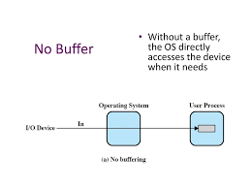

* The process must wait I/O t complete before the proceeding
* Problems
  + Programs hang up waiting for the relatively slow I/O to complete
  + It interferes with swapping decisions by OS

**Buffering**

* It will be more efficient to perform input transfer in advance of request being made and to perform output transfers some time after the request is made

**Block Oriented Buffering**

* The information is stored in a fixed sized blocks
* It transfers are made a block at a time
* Block number can be a reference data

**Stream Oriented Buffering**

* Terminals, printers, communication ports, mouse and other pointing devices is I/O devices that is for steam oriented
* Transfer information as a stream of bytes

**Single Buffer**

* It is assigned buffer in the system portion of the main memoery where for an I/O request

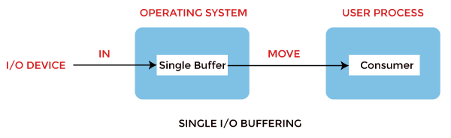

**Double Buffer**

* Using two system buffers
* Can transfer data to or from one buffer while os empties or fills the other buffer

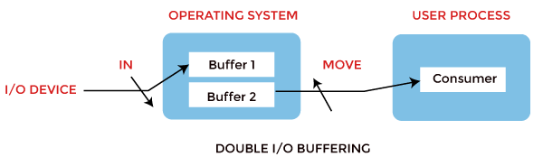

Circular Buffer

* More than 2 buffers are used
* Each individual buffer is a one unit in a circular buffer
* It followed the bounded buffer producer/ consumer

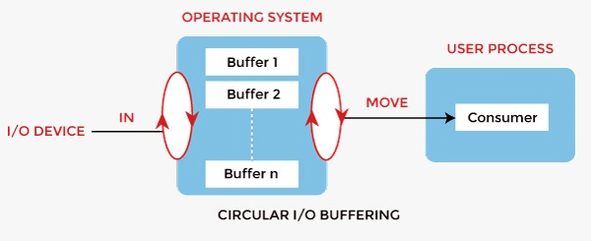

**Disk scheduling**

* Disk are at least four orders of magnitude slower than main memory
  + Performance of disk storage sub system is of vital concern
  + General timing diagram

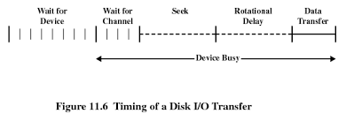

**Disk performance parameters**

* **Access time**
  + Sum of seek time
    - Time it takes to position the head at the desired track
  + Rational delay/ rational latency
    - Time it takes for the beginning of the sector toreach the head
* Transfer time
  + Time taken to transfer data
* Total average access Time Ta

Ta = Ts + 1 / (2r) + b/ (rN)

**Disk Scheduling policies**

* **FIFO (First in First Out)**
  + It is process request sequentially, fair to all process, may have good performance if most request are to clustered file sectors, approach random scheduling in performance if there are many processes.



**Last in last out**

* Good for transaction processing system
* Possibly of starvation since a job may never regain the head of the line

**Shortest Service time first**

* Always choose the minimum seek time.

**Scan**

* arm moves in one direction only satisfying all outstanding request until it reaches the last track in that direction then the direction is reversed

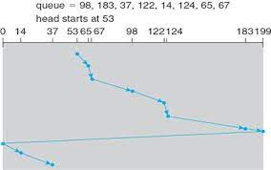

**CSCAN**

* Restricts scanning to one direction only
* Reduces the maximum delay experienced by new request

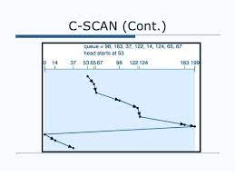

**Chapter 7**

**File System**

**File System Hierarchy (FHS)**

Red hat Enterprise Linux was developed by the red hat for the business market it is an Enterprise linux operating system RHEL known as Red Hat Linux advance Server is certified with thousand of vendors and across hundreds of clouds. It provides with a reliable consistent foundation across environments it is equipped with all the necessarily tools to rapidly deliver application services and workloads it was based on free open source model like all Linux distribution red hat has two version it is the RHEl and the other one is the fedora that is developed by the fedora project it undergoes more frequent version releases and offers the latest available technologies . large community of the developers was actively contributing on the fedora project but Red hat takes features the fedora project develops and incorporates them into rhel.**FHS**  or what we called also the file system hierarchy standard was the file system structure where the red hat linux uses because it defines the names, locations, and also the permissions. **FHS ORGANIZATION** the directories and also the files was noted here in a small subset of those fhs document.

/boot/ - directory that contains static files it requires to boot the system such as the linux kernel

/dev/ - directory that contains file system entries which represent as the devises that attached to the system.

/etc/ - directory that reserved for the configuration files that are local to the machine no binaries are to be placed .

/lib/ - directory should contain only those libraries needed to execute the binaries /bin/ and also the /sbin. Those are really important on booting the system and also executing commands within the root file system.

/media/ - directory that contains sub directories that used as mount points for removable media.

/mnt/ - directory that is reserve for temporary mounted file system like the nfs like system mounts.

/opt/ - directory that provides storage for large , static application software packages This directory in turn, holds files that otherwise would be scattered throughout the file system.

/proc/ - directory that containes special files the extract information from or send information to the kernel.

/sbin/ - directory stores executables used by the root user. It contains binaries essential for booting, restoring, recovering, and/or repairing the system in addition to the binaries in /bin.

/sys/ - derectory that utilizes sysfs virtual file system specific to the 2.6 kernel.

/usr/ - directory that for files that can be share in multiple machines.

/usr/local hierarchy is for use by the system administrator when installing software locally. It needs to be safe from being overwritten when the system software is updated. It may be used for programs and data that are shareable among a group of hosts, but not found in /usr.

Example:

/usr/local

|- bin/

|- etc/

|- games/

|- include/

|- lib/

|- libexec/

|- sbin/

|- share/

|- src/

The FHS says that /usr/local/ should be where software that is to remain safe from system software upgrades is stored. Since software upgrades can be performed safely with RPM Package Manager (RPM), it is not necessary to protect files by putting them in /usr/local/. Instead, the /usr/local/ directory is used for software that is local to the machine.

/var/ - variable data files. This includes spool directories and files, administrative and logging data, and transient and temporary files.

**Example of the var directory:**

**/var**

|  |  |  |  |  |
| --- | --- | --- | --- | --- |
| **|- account/** | **|- arpwatch/** | **|- cache/** | **|- crash/** | **|- db/** |
| **|- empty/** | **|- ftp/** | **|- gdm/** | **|- kerberos/** | **|- lib/** |
| **|- lock/** | **|- log/** | **|- mail -> spool/mail/** | **|- mailman/** | **|- named/** |
| **|- nis/**  **|- at/** | **|- opt/**  **|- clientmqueue/** | **|- preserve/**  **|- cron/** | **|- run/**  **|- cups/** | **+- spool/**  **|- exim/** |
| **|- lpd/** | **|- mail/** | **|- mailman/** | **|- mqueue/** | **|- news/** |
| **|- postfix/** | **|- repackage/** | **|- rwho/** | **|- samba/** | **|- squid/** |
| **|- squirrelmail/** | **|- up2date/** | **|- uucp** | **|- uucppublic/** | **|- vbox/** |
| **|- tmp/** | **|- tux/** | **|- www/** | **|- yp/** |  |

**References**

**History of Fedora Linux**

**<https://www.javatpoint.com/fedora-operating-system>**

**<https://www.geeksforgeeks.org/fedora-operating-system/>**

**<https://fedoraproject.org/>**

**Process management of fedora linux**

**<https://www.oreilly.com/library/view/fedora-linux/0596526822/ch04s09.html#:~:text=Fedora%20provides%20multiple%20tools%20to,nice>**

**<https://www.javatpoint.com/fedora-operating-system>**

**<https://docs.fedoraproject.org/en-US/program_management/>**

**Cpu scheduling of Fedora linux**

**<http://www.hasanbalik.com/LectureNotes/OpSys/Assignments/Linux%20(Fedora%20or%20Slackware)%20CPU%20Scheduling.pdf>**

**<https://forums.fedoraforum.org/showthread.php?262468-cpu-scheduling-algorithm>**

**Memory management of fedora linux**

**<https://fedoramagazine.org/understand-fedora-memory-usage-top/>**

**<https://discussion.fedoraproject.org/t/memory-usage-doesnt-add-up-most-of-the-ram-gone-mysteriously/77052>**

**Storage management of fedora linux**

**<https://docs.fedoraproject.org/en-US/fedora-coreos/storage/>**

**<https://www.oreilly.com/library/view/fedora-linux/0596526822/ch04s03.html>**

**<https://fedoramagazine.org/storage-management-with-cockpit/>**

**<http://www.hasanbalik.com/LectureNotes/OpSys/Assignments/Linux%20(Fedora%20or%20Slackware)%20Memory%20Management.pdf>**

**I/O systems of fedora linux**

**<http://www.hasanbalik.com/LectureNotes/OpSys/Assignments/Linux%20(Fedora%20or%20Slack>**

**<https://www.javatpoint.com/fedora-operating-system>**

**File systems of Fedora Linux**

**<https://access.redhat.com/documentation/en-us/red_hat_enterprise_linux/4/html/reference_guide/s1-filesystem-fhs>**